1. Go to Github using this URL:

https://github.com/SFDO-Community-Sprints/NPSPImport-Excel-Formatter

1. Under the Code tab, select the latest version of the **Household Formatter** xlsm file

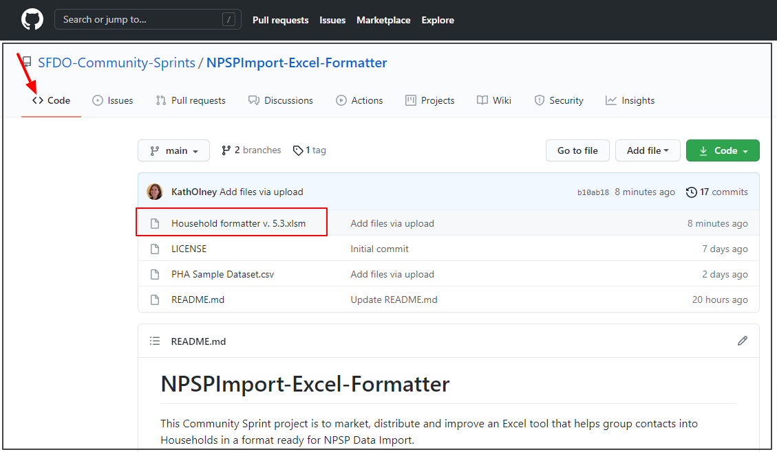

1. Select Download

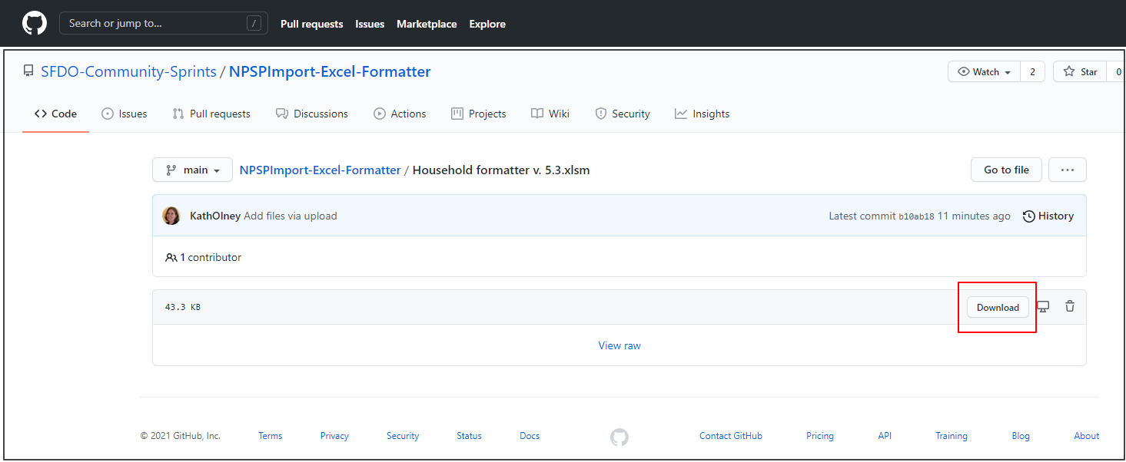

1. Open the downloaded xlsm file. If prompted, enable editing

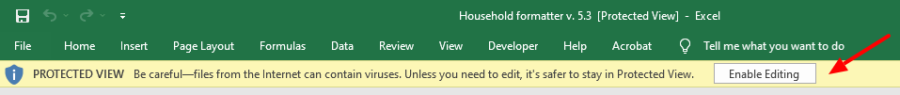

1. If prompted, enable macros. Macros must be enabled for the tool to work. Macros may also be enabled through File > Options > Trust Center > Trust Center Settings > Macro Settings  
     
   